Steps :

1. Use Azure Boards App to create EPIC, Feature, User Story, Tasks, Test Cases, Defects and Execution of Sprints.
2. Create Maven project in Visual Studio and commit the same on Azure Repo.
3. Use Azure Repo to Create feature branch from main, commit code to feature branches, create pull request to merge into main branch.
4. Access for Agent Pool
5. Create a VM for configuring the Self Hosted Agent
6. Configure Agent on VM
7. Create Container based Web App for SonarQube Server Set up
8. Create Code based Web App for Deployment of our App
9. Install and Configure SonarQube in Azure DevOps
10. Install Whitesource Mend Bolt tool
11. Create CI Pipeline
with maven package, test, SonarQube scan, Whitesource Mend Bolt scan and publish
12. Create Release Pipeline
13. Triggered execution of CI and deploy on UAT, deploy on Prod after manual approval

Azure Boards
Using Import Work Items option, uploaded Epic, Backlog and Tasks into Azure Board
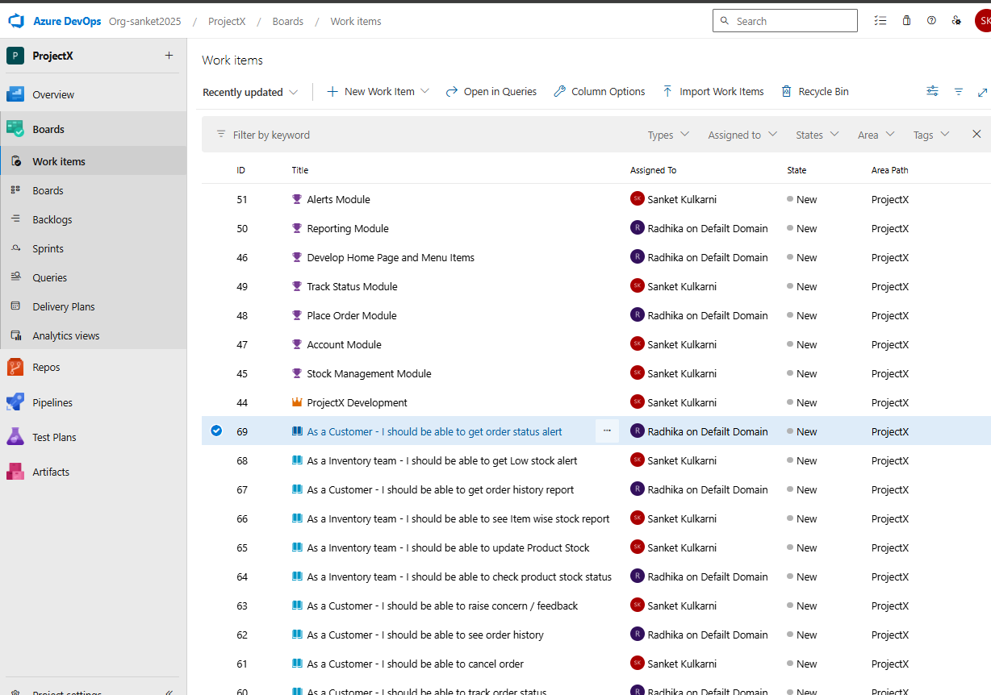

Backlog distributed across 3 sprints considering the priority and capacity of team 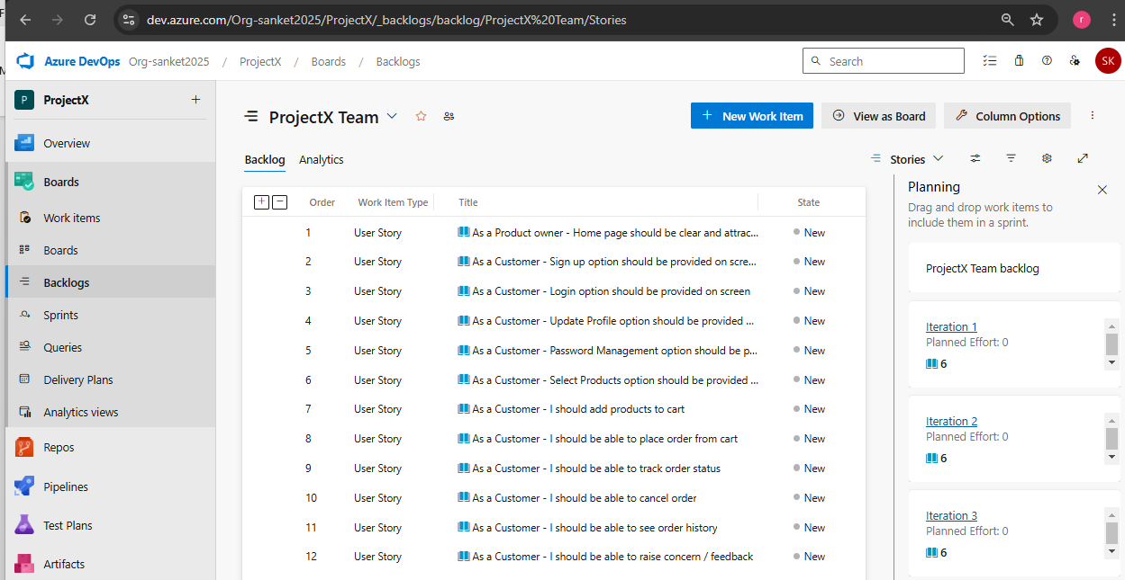

Azure Repo -> Code commited to Azure Repository 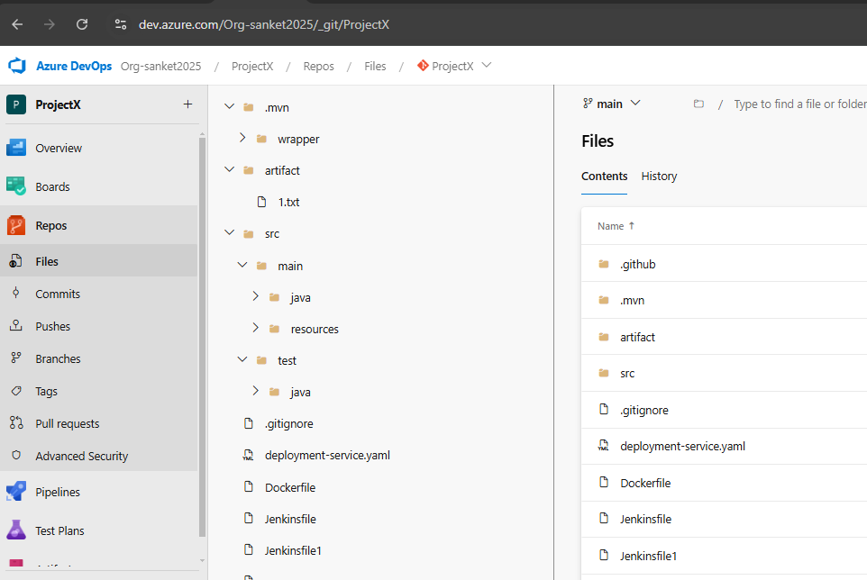
Create feature specific branch from main branch
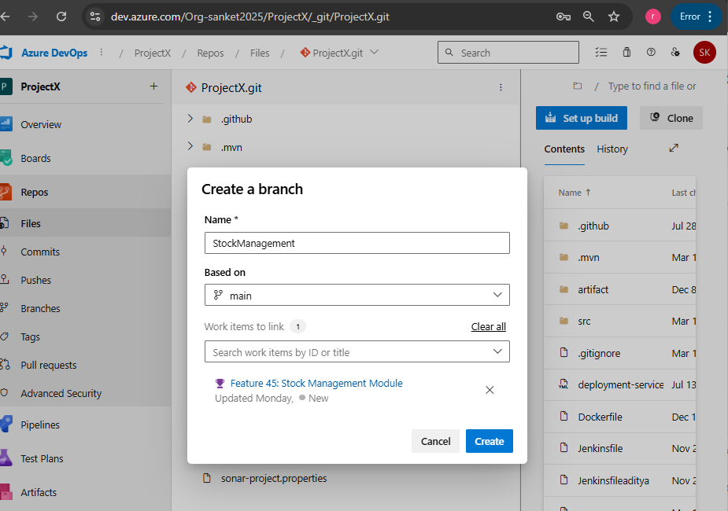
New feature developed and committed to feature branch.
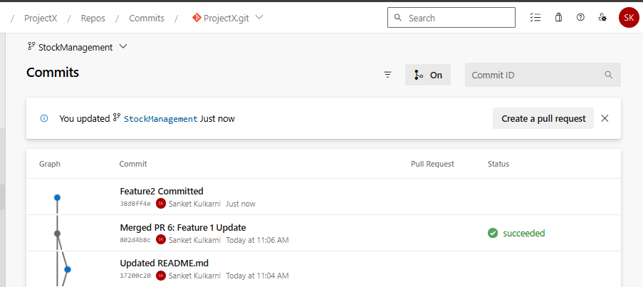
Merge Request for changes committed to Feature branch to main branch
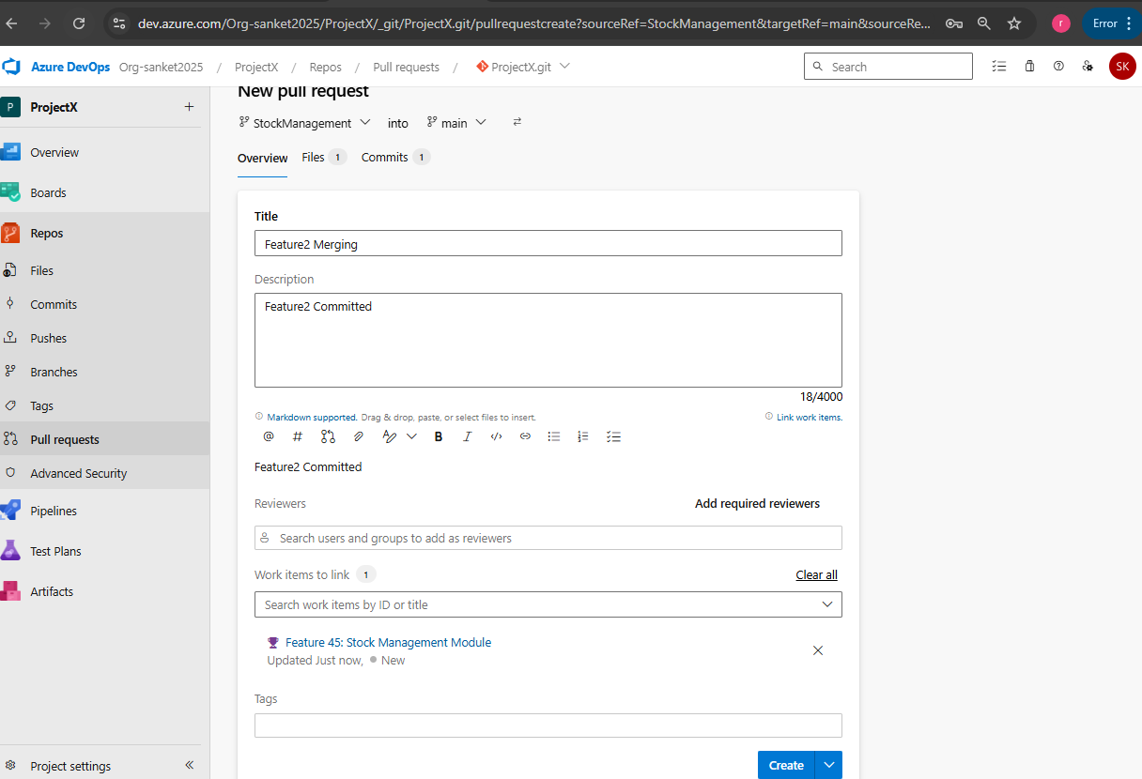

Approve the pull request and complete.
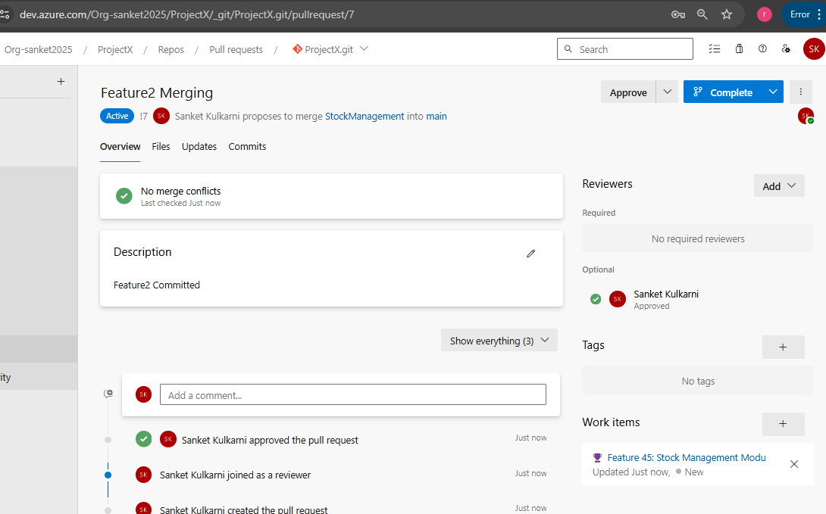
Complete Merge / pull request
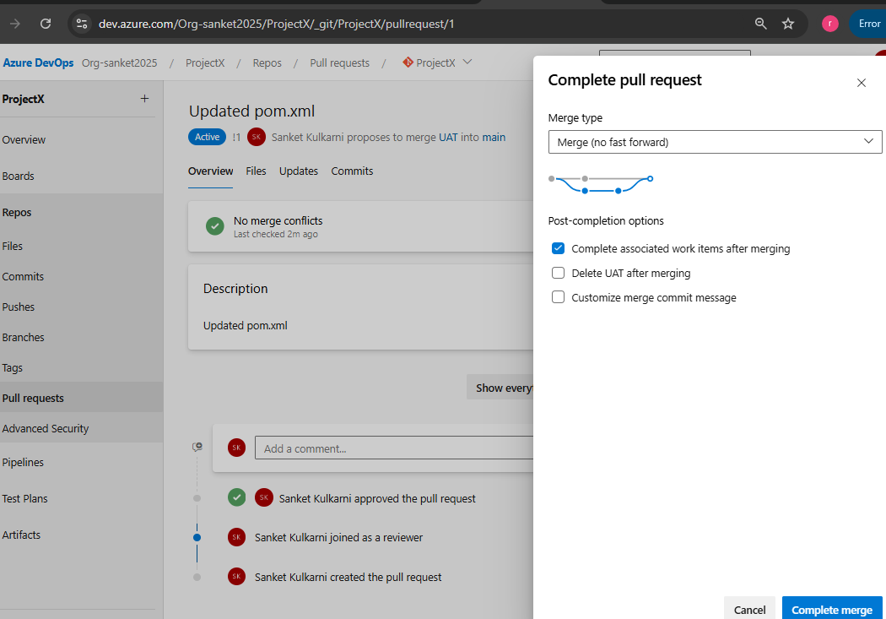
Self Hosted Agent
Go to Organization -> Settings -> Agent Pools -> Security
Add the account which will be used for registering the Self Hosted Agent
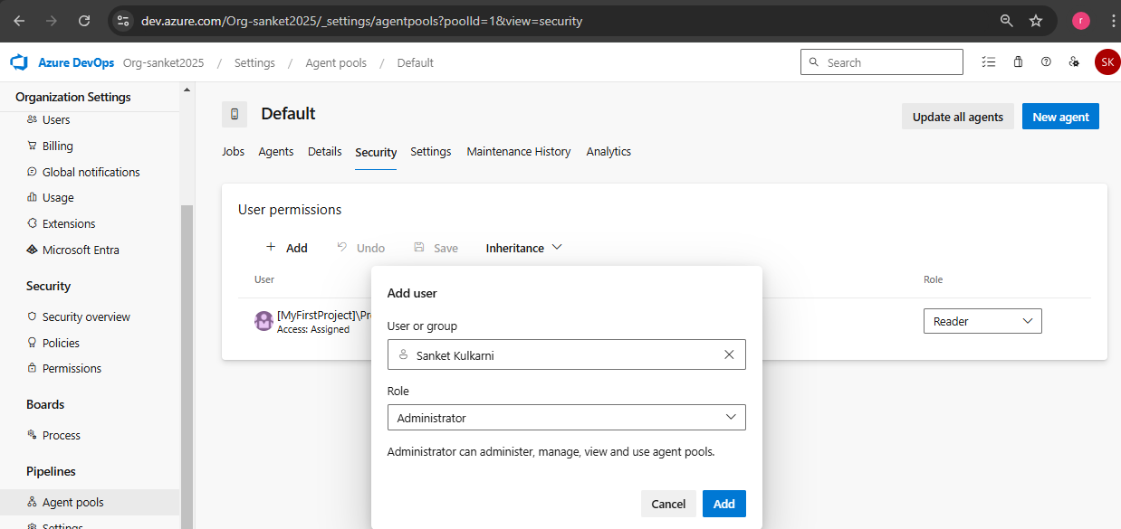
Create PAT for Agent Pool Access in Agents tab
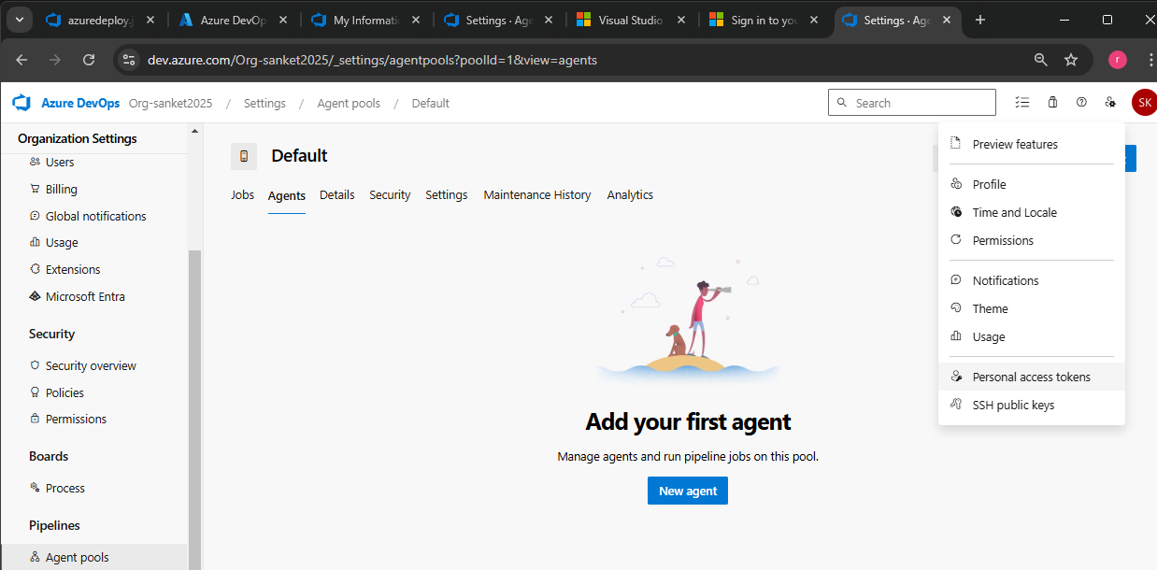

Select Agents Pool Accesses as shown below
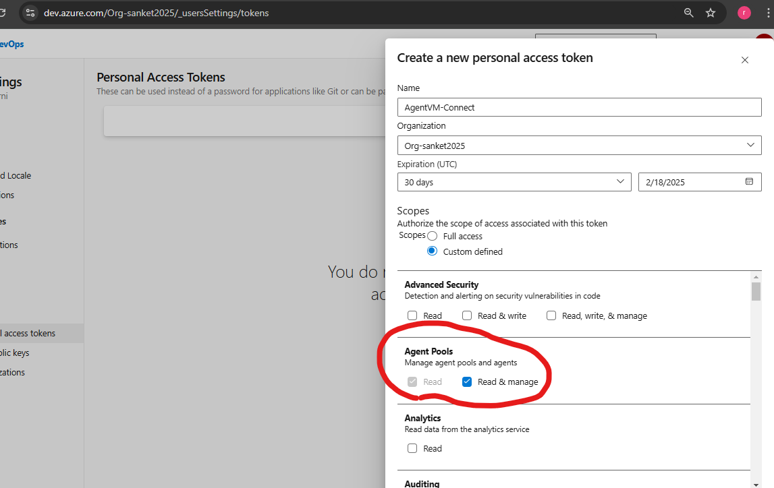
VM Creation for Self-Hosted Agent
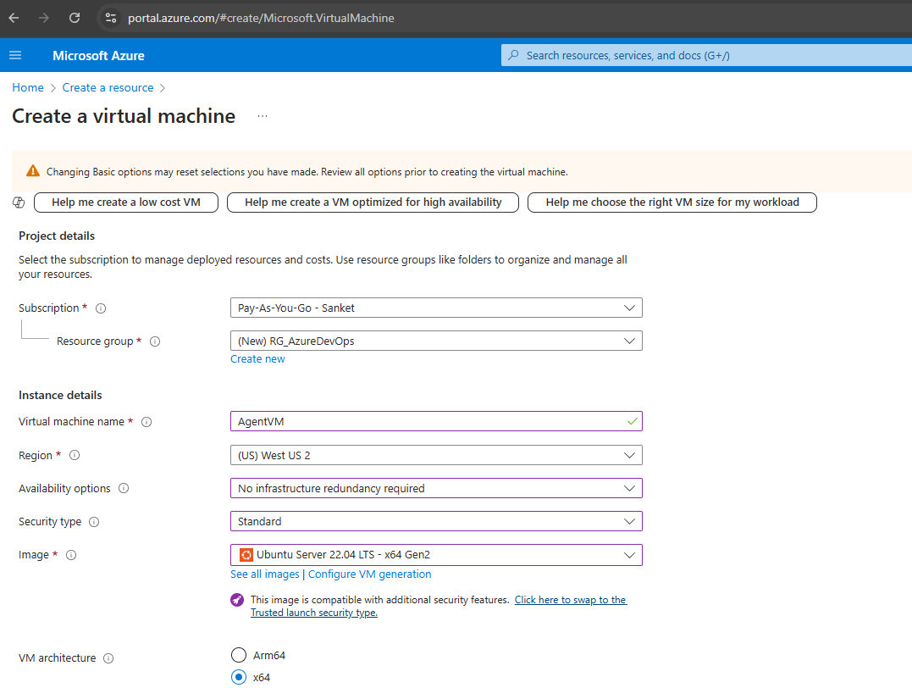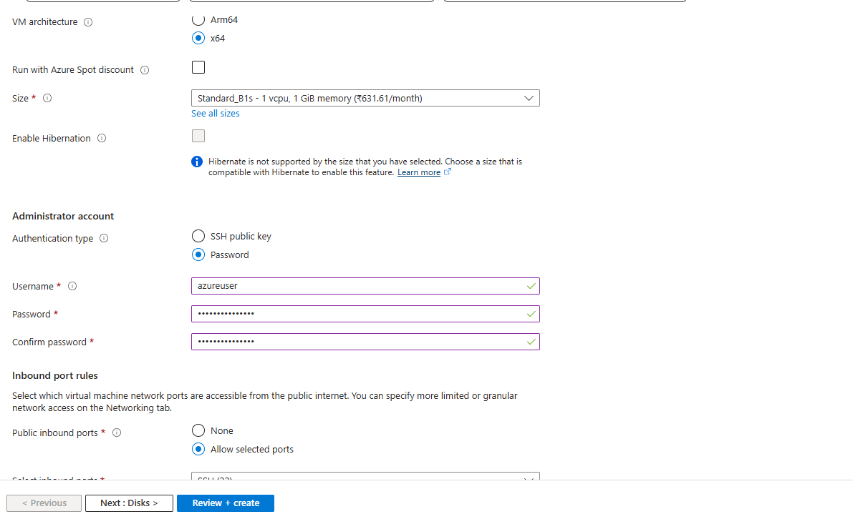
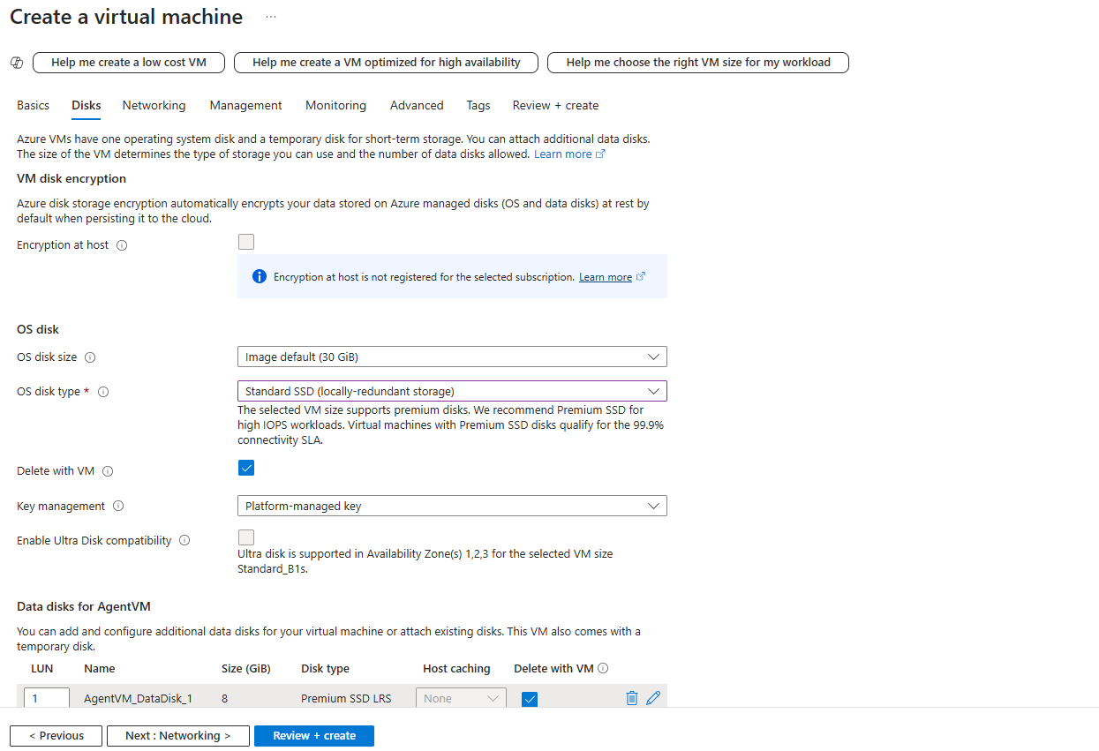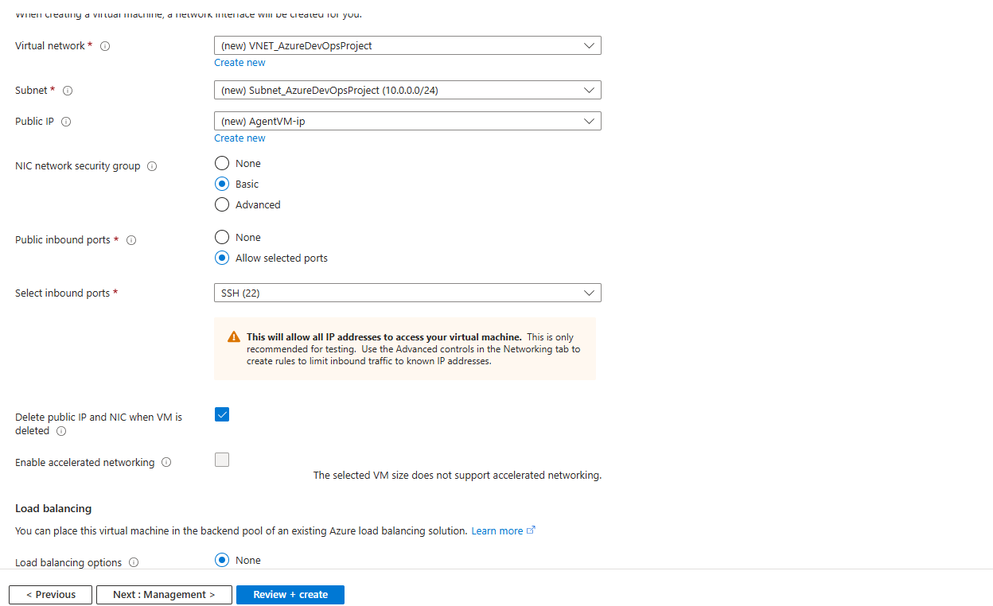

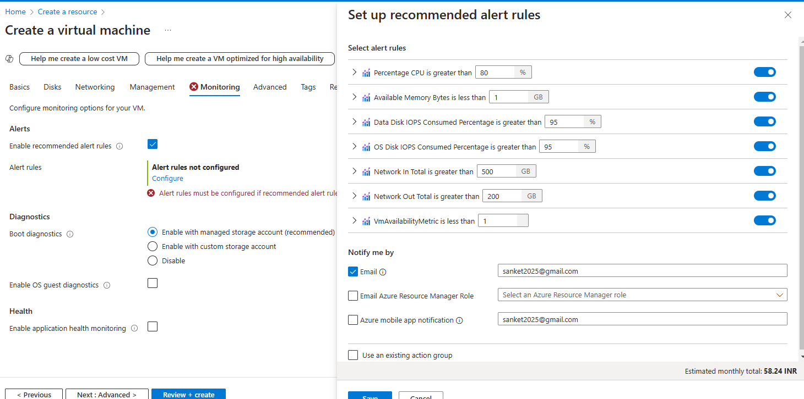

Login to Agent VM using Putty
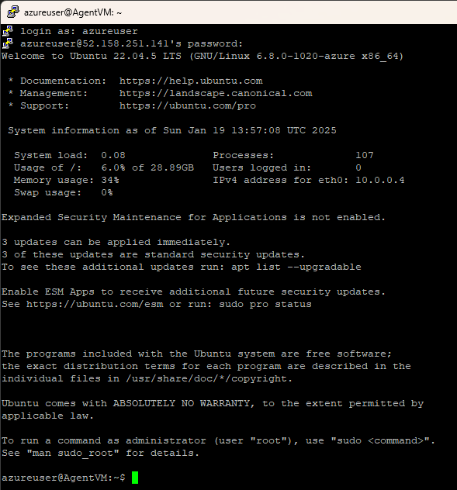
Install Java on the VM
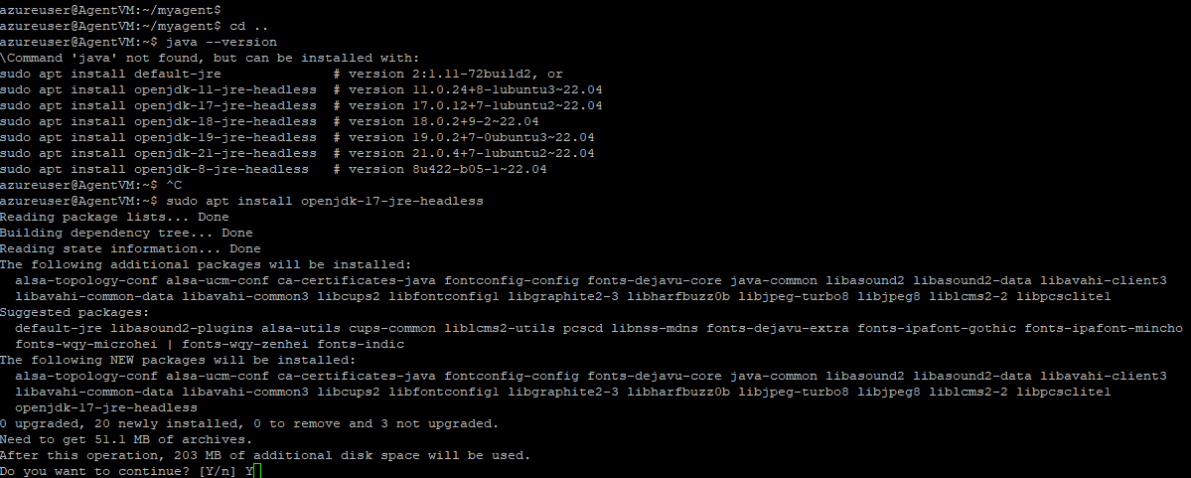
Install maven on the VM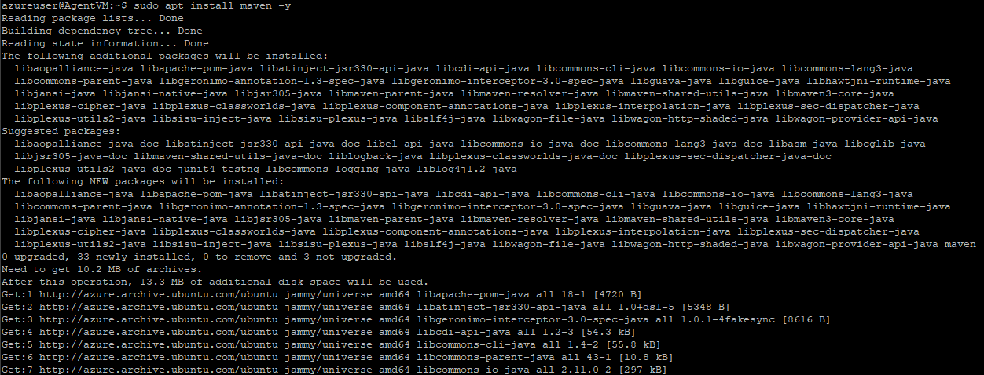

To Configure this VM as an Agent for our pipelines
Execute Below commands
wget https://vstsagentpackage.azureedge.net/agent/4.248.0/vsts-agent-linux-x64-4.248.0.tar.gz
mkdir myagent && cd myagent
tar zxvf ../vsts-agent-linux-x64-4.248.0.tar.gz
./config.sh -- Enter this command, Enter Y when asked for PAT and enter the PAT generated earlier and other inputs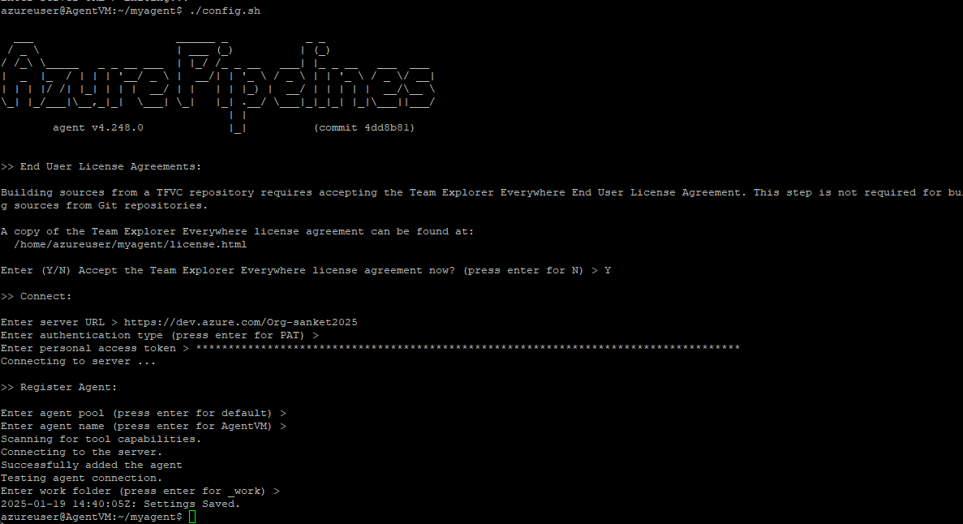

Execute Command to enable the agent -> ./run.sh
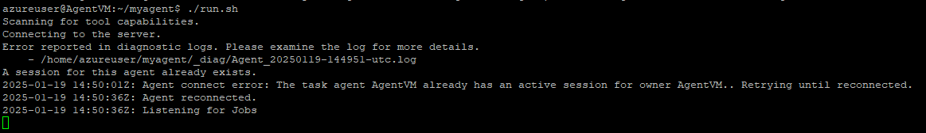

Add Capabilities for the Agent -> maven and java
Maven
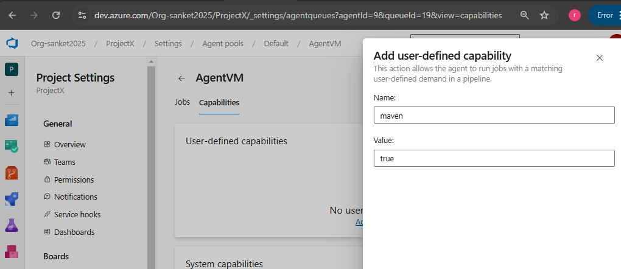

Java
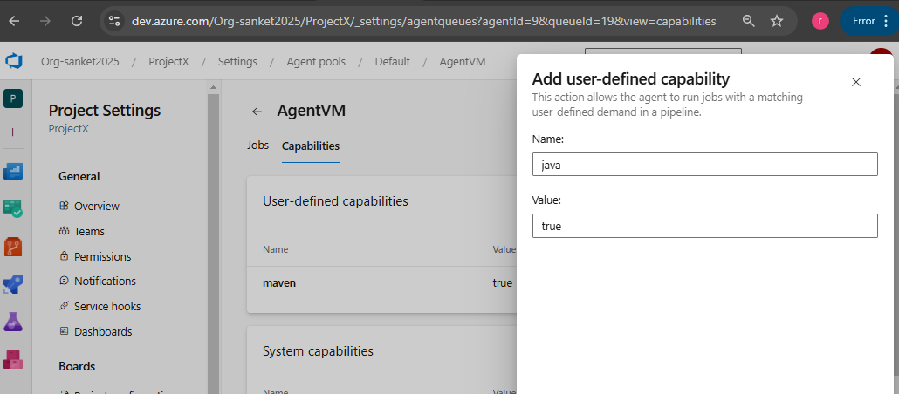

Web App for SonarQube Server ( Similarly create Web app with code option to deploy our UAT and Prod Applications)
Creating Web app with the container image for the same – Refer container image and tag details here https://hub.docker.com/_/sonarqube/tags
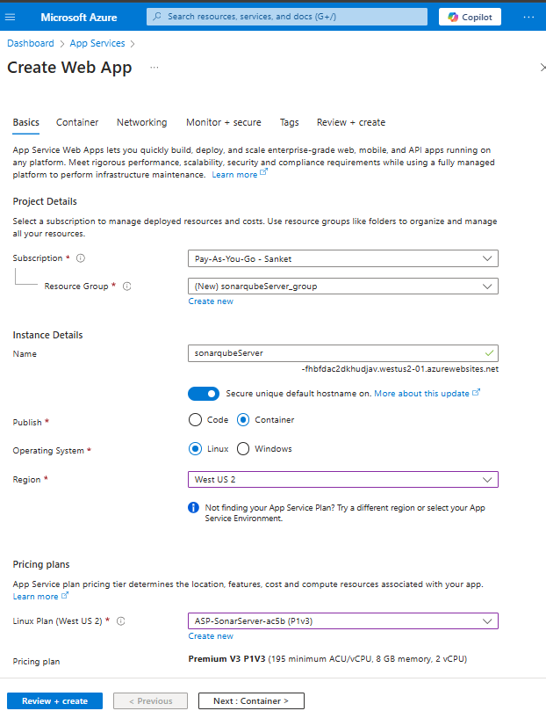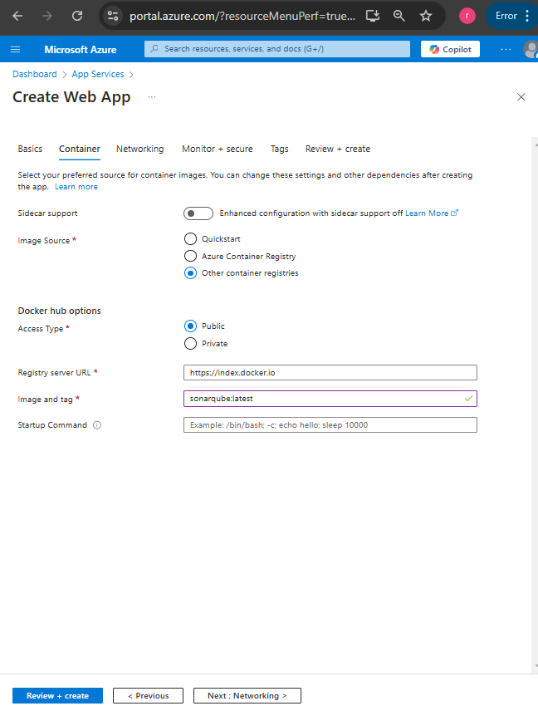
As its very slow changed the Plan type to Premium as below
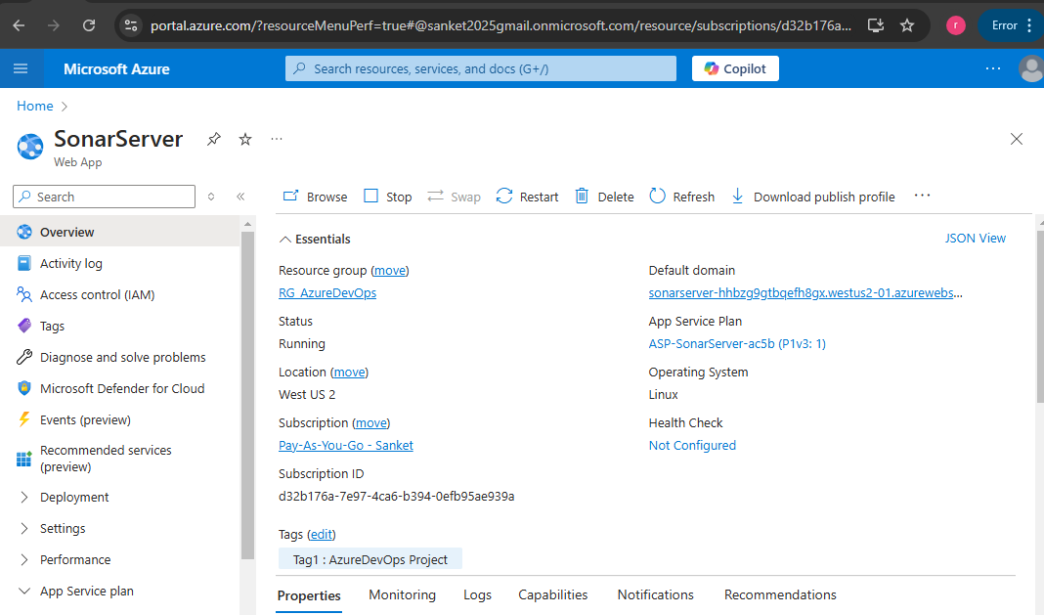
Click on Browse / Default Domain to open the sonar server URL -> Enter default credentials as below
Username – admin password – admin and update new password -> Login with new password
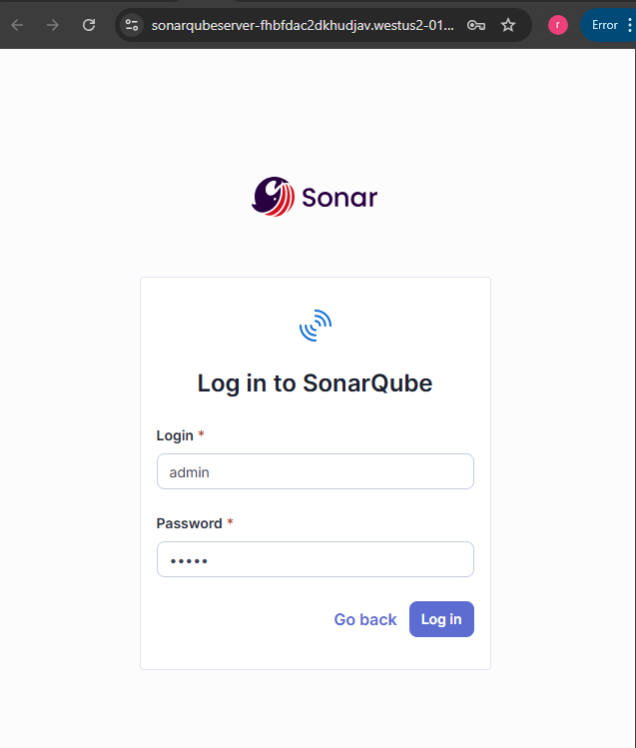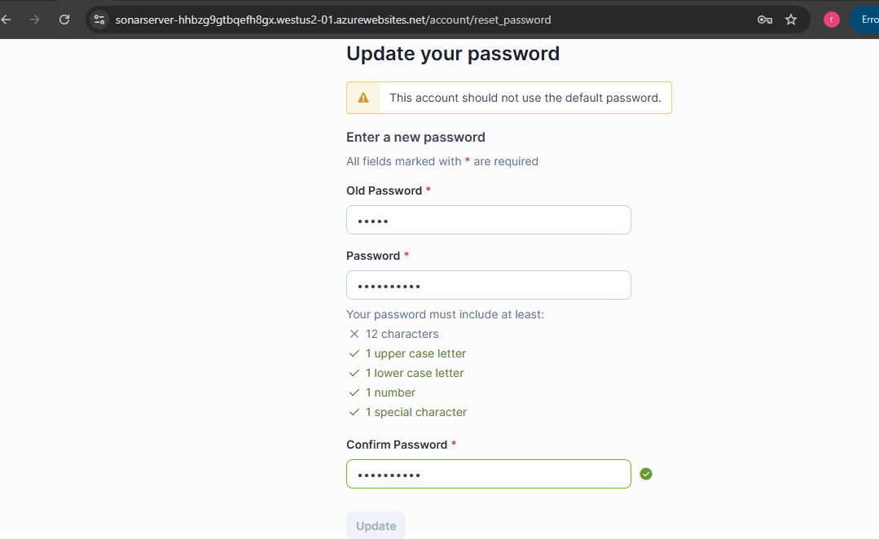

Create a Token which can be used to connect to SonarQube server from Azure Pipeline
Click on Symbol A at the top right corner -> My Account -> Security -> Generate Tokens -> Add details and Generate
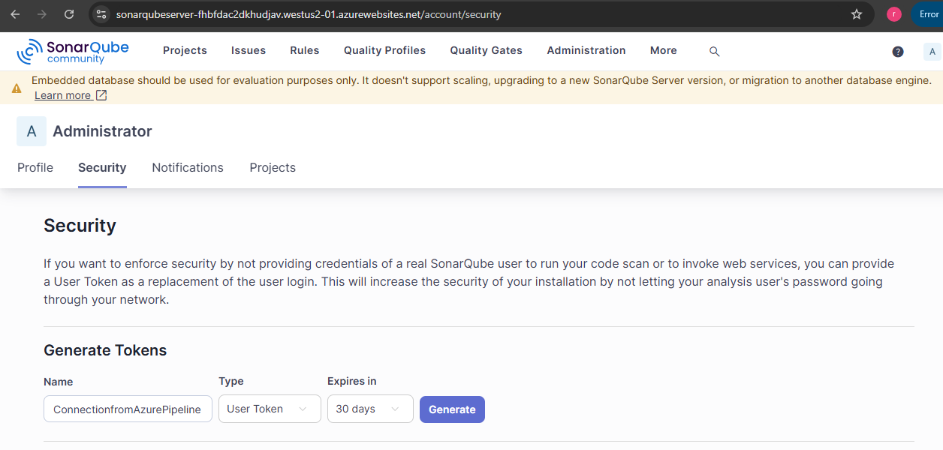

Install SonarQube Cloud Extension / Plugins in Azure Devops: Click symbol shown below -> Browse Marketplace
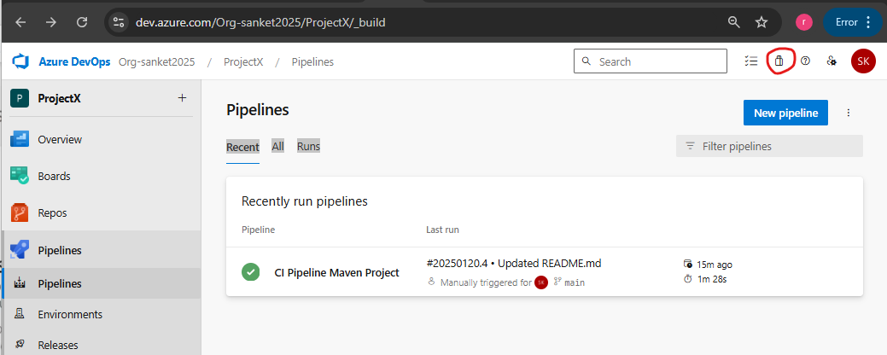
Search SonarQube and click on the symbol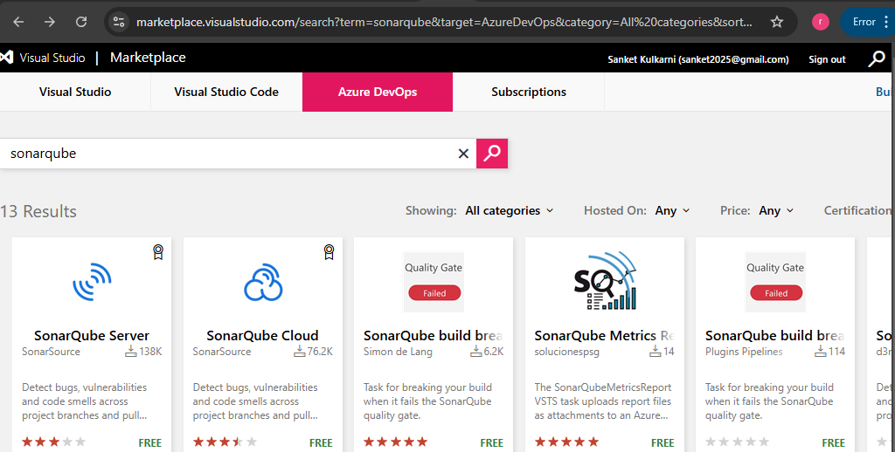
Click on get it for free Select Organization and click on Install
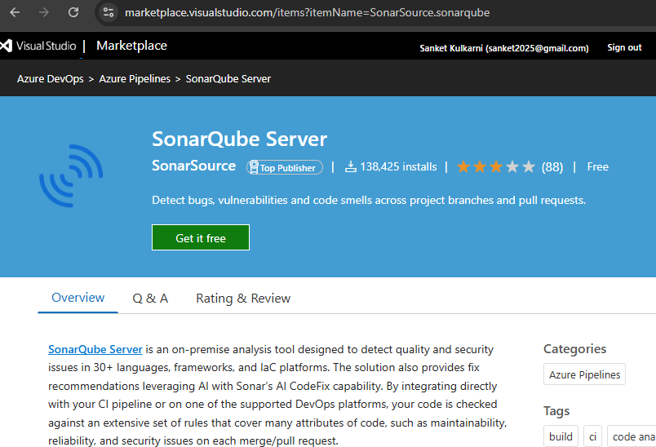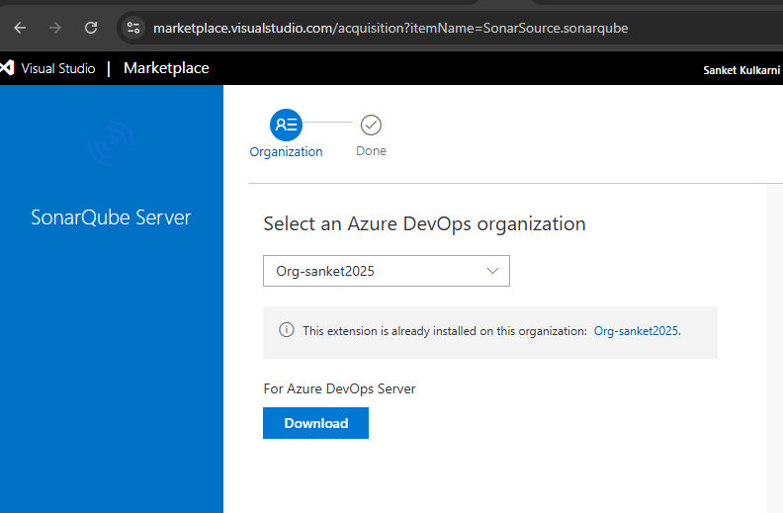
Install Mend Bolt (WhiteSource) also in same way
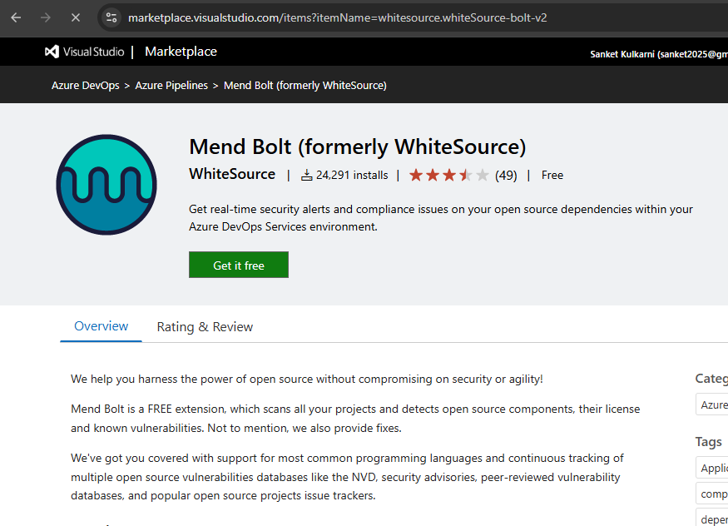
Go to Organization Settings -> at the bottom click on Mend -> Fill the form and Click on Create Account
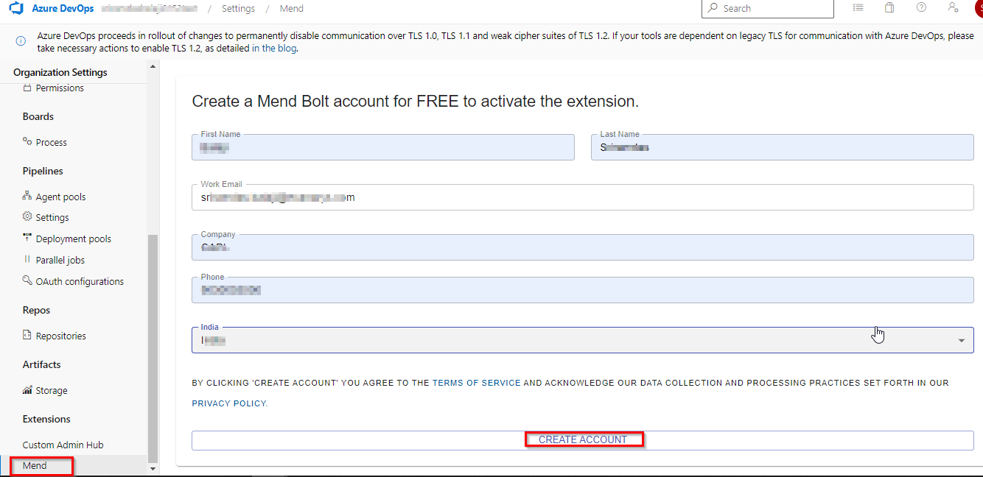

Go to Pipeline Menu -> Create Pipeline -> Select Option at the bottom – Use the classic editor
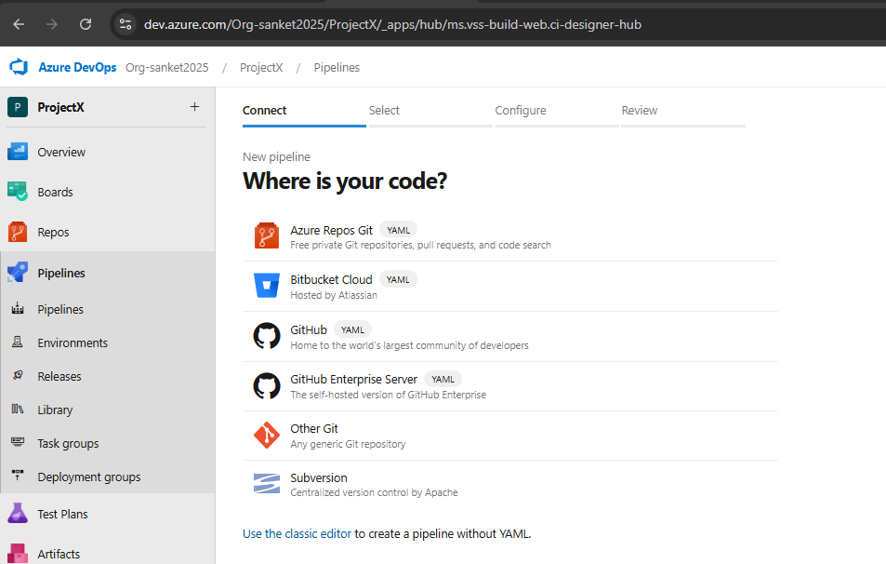

Select Repository and other details as shown below –> Click on Continue
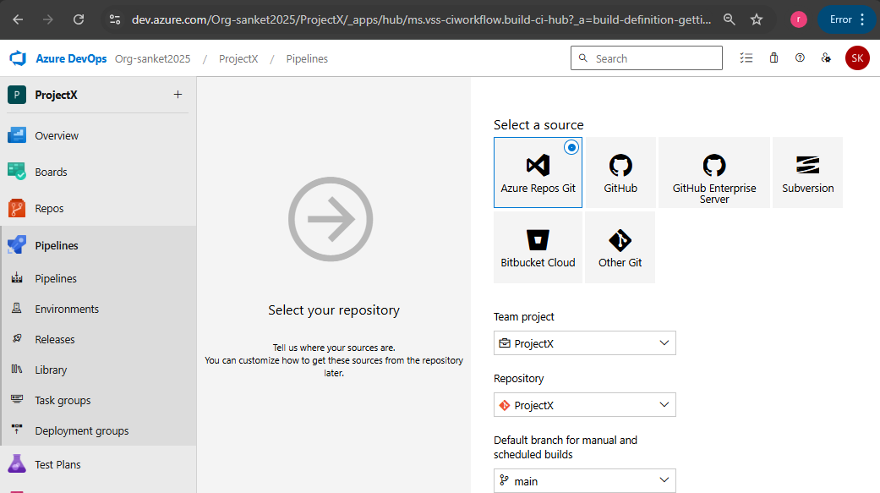

Search Maven Task and click on Apply
Edit the Name as required, Select Agent Pool as Default (for which we configured Self Hosted Agent earlier)
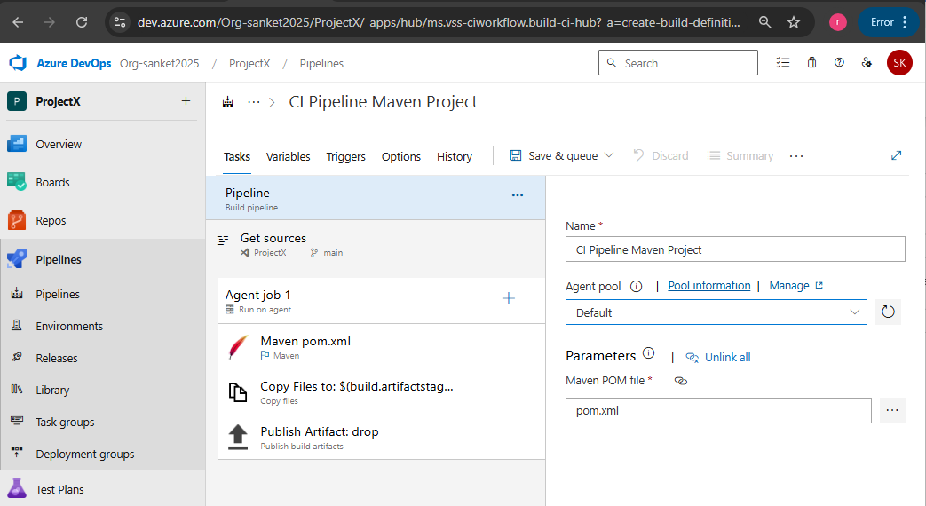

Add Trigger for CI Pipeline
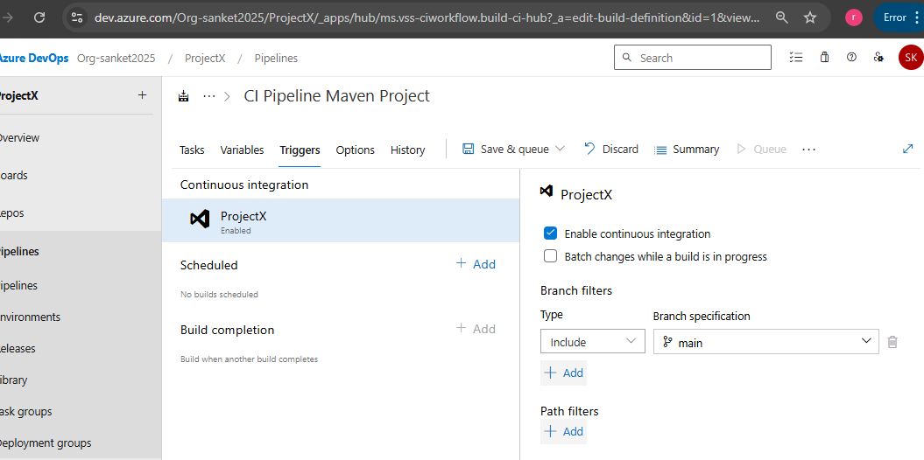

Add SonarQube Tasks in Azure Pipeline
Click + symbol to add new task and select Sonar and click on add for Prepare Analysis Configuration
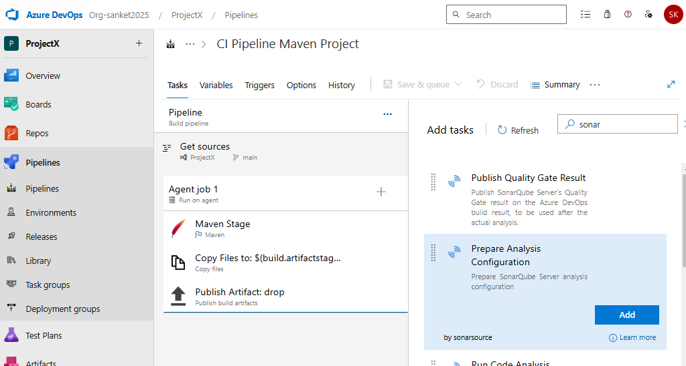

Click on +New button to add a new Service Connection as below -> Click on Save
Server URL : Take URL from Resource name (Web App created for SonarQube Server) including Https://
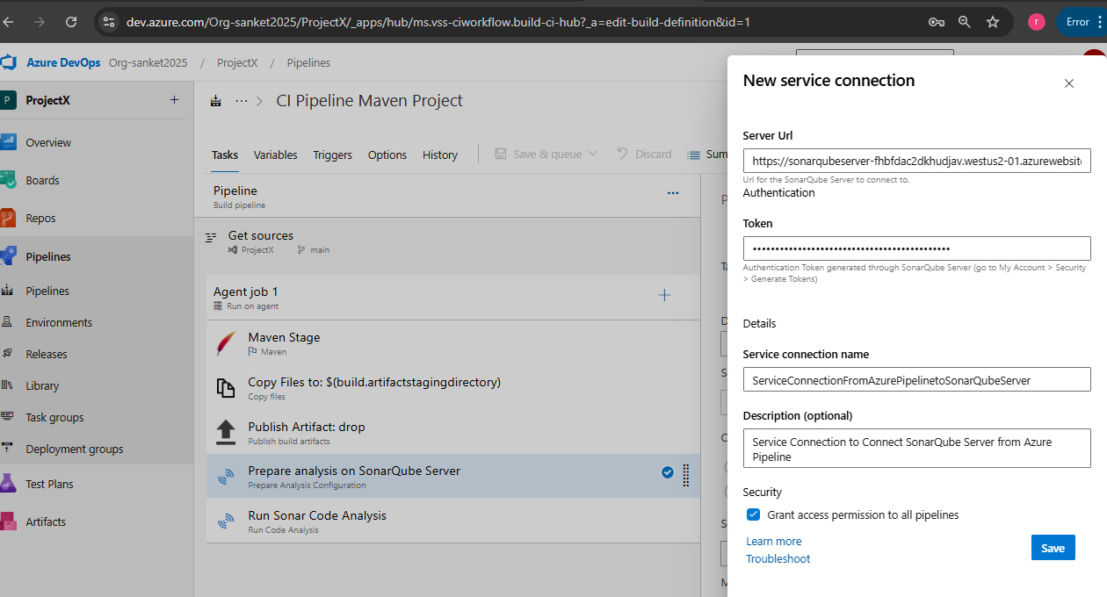
Sonar-project.properties file is as below (available in Repo)
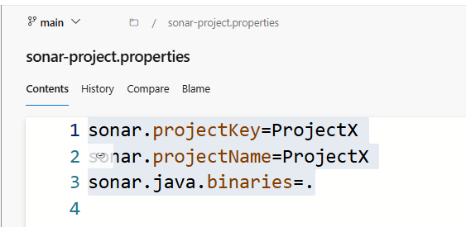

Add another task to run sonar Code Analysis and click on Save
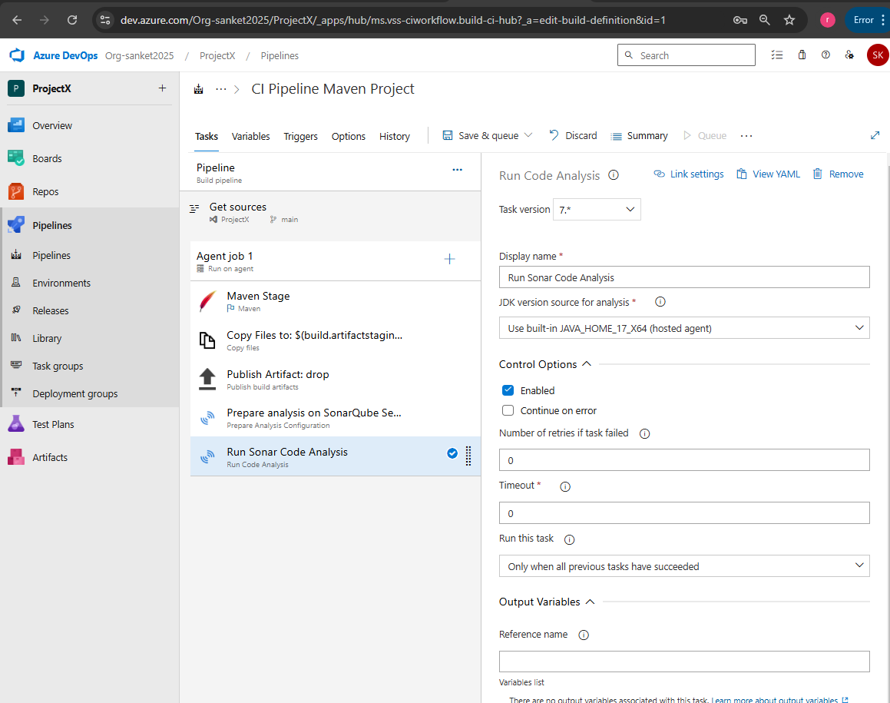

Add another task for Mend Bolt
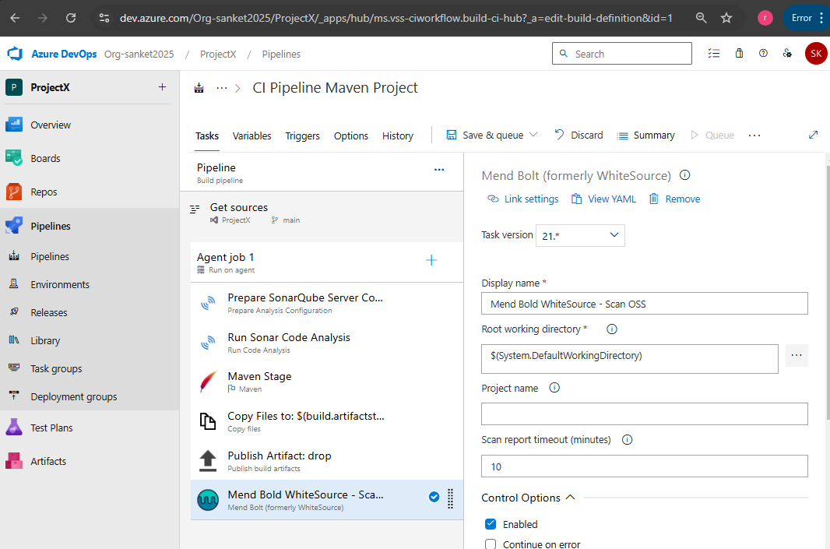

Release Pipeline: Go To Pipelines -> Release ->
Click on Add Artifact -> select details as shown below and click on Add
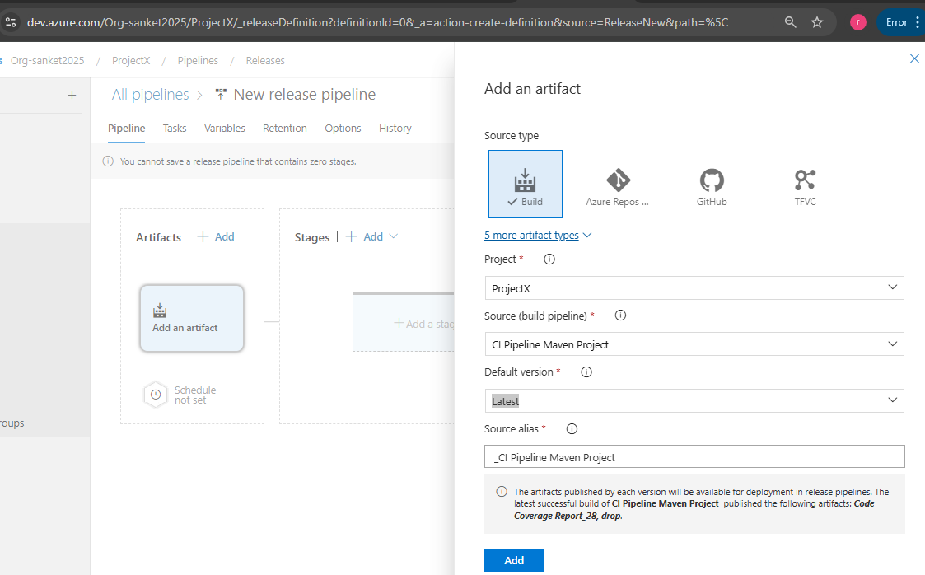
Add Trigger for Continuous Deployment
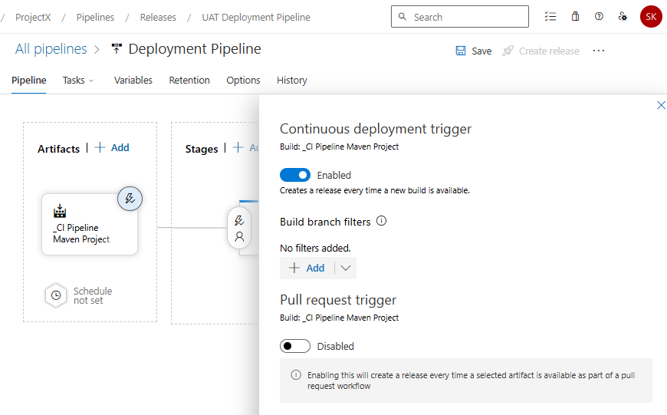
Click on New Stage -> Select Azure Web App Deployment-> Click on Apply
-> Modify Stage Name: UAT Stage
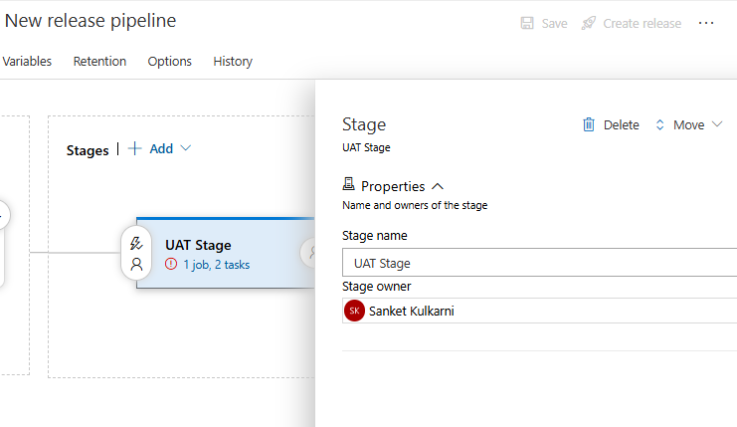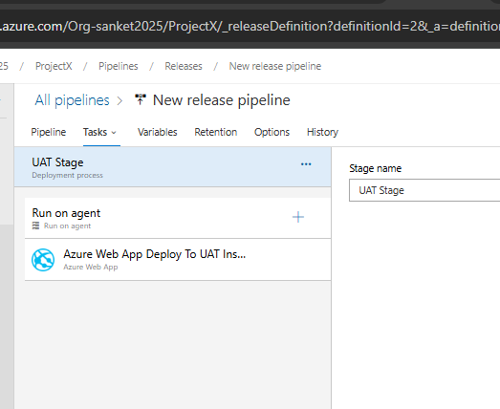
Open Each Task one by one and update details as required -> IF already not present, Authorize pipeline to connect to the Azure App service (It will create service principal) -> Click on Save, do the changes in next steps as per the screenshots ( Copy Slot name, app service name, resource group name from the created app service.
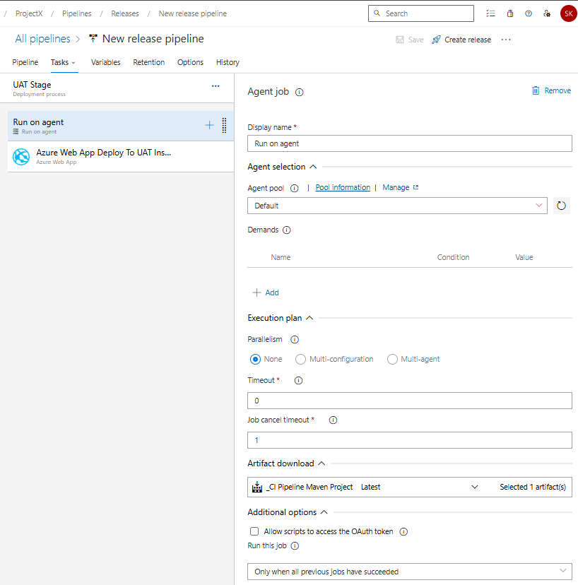
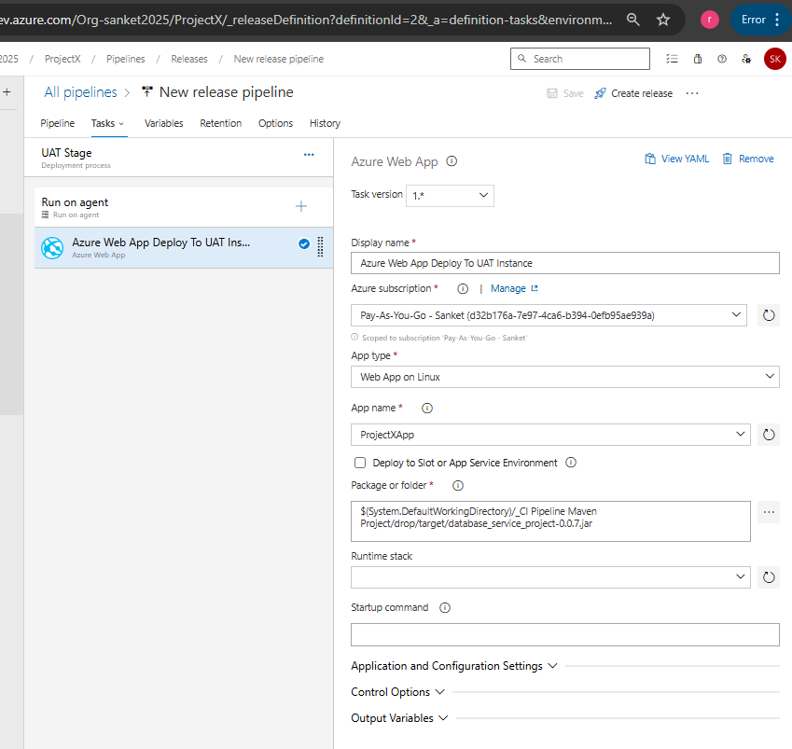
Just Create Trigger from Build Artifact generated. No pre-deployment conditions / approvals required for UAT Stage
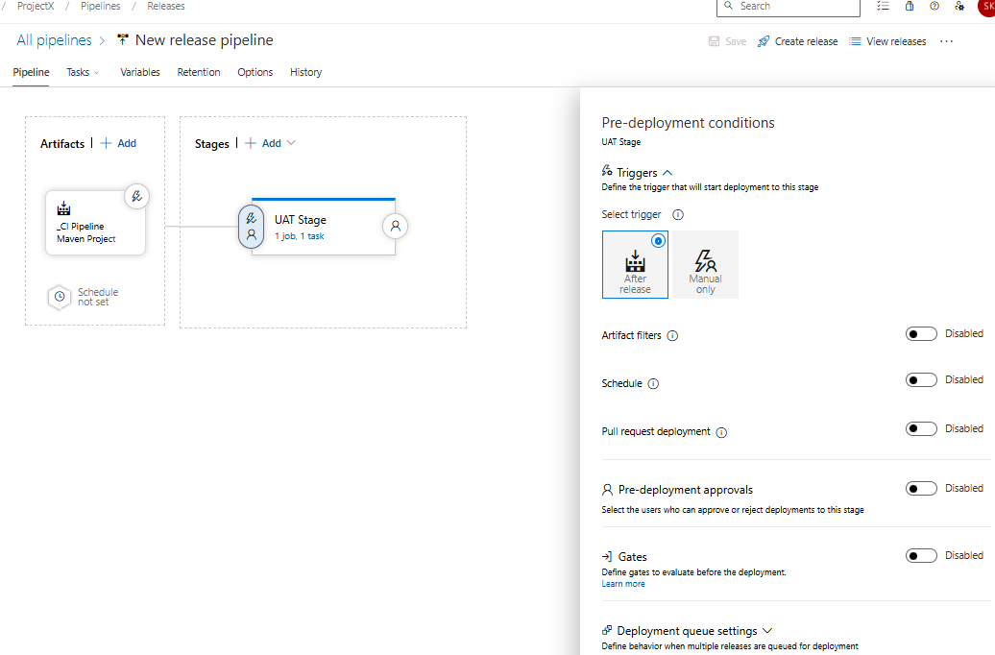

Click on Clone Stage and rename the new copy as Production Stage and Update each stage as below
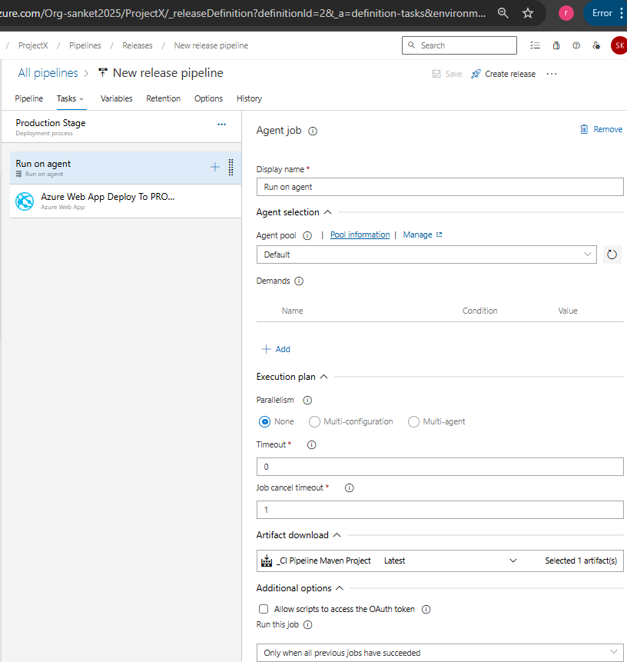
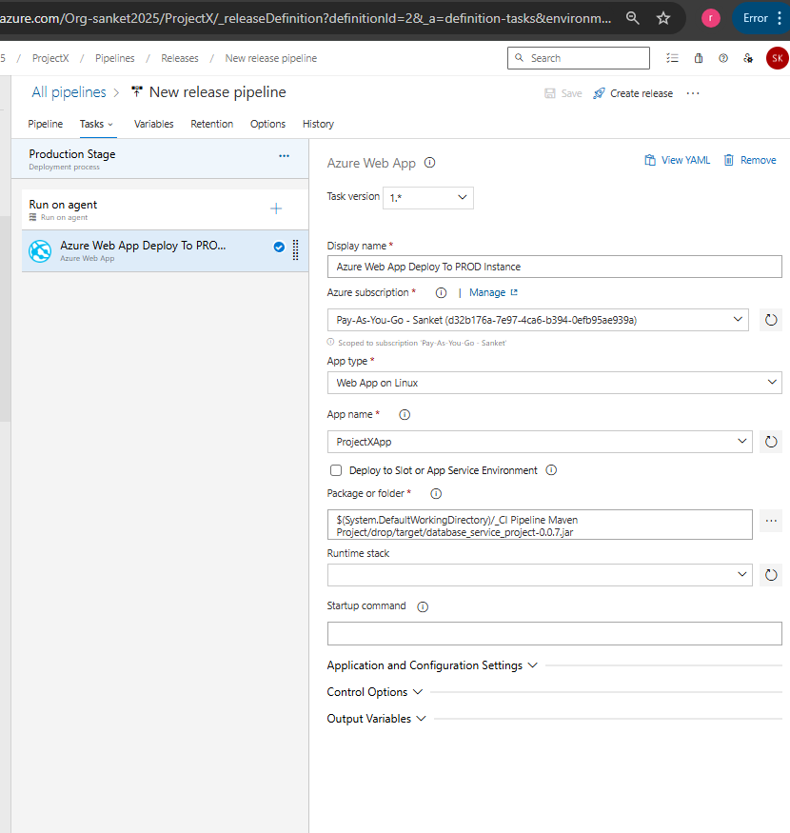
Pre-Deployment for Prod -> Allow Manual Deployment only. Also required pre-deployment approval.
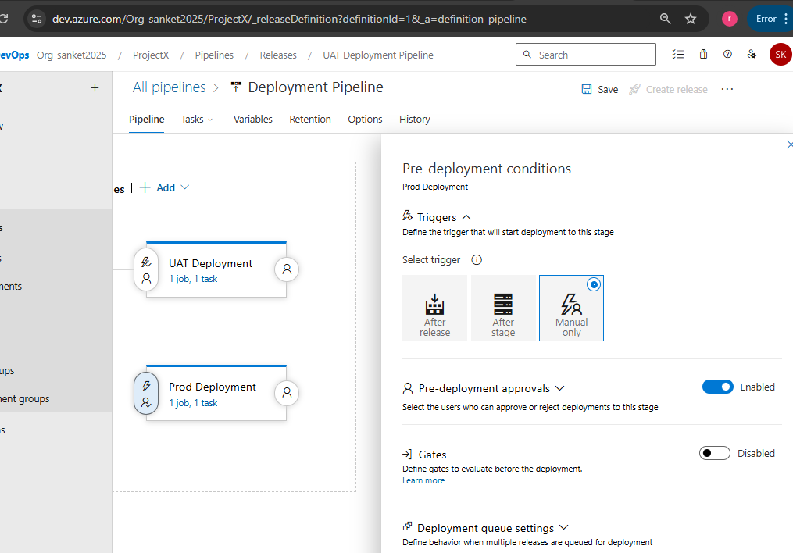

CI Pipeline triggered automatically once pull request completed on main branch (pipeline was renamed earlier to debug some issues)
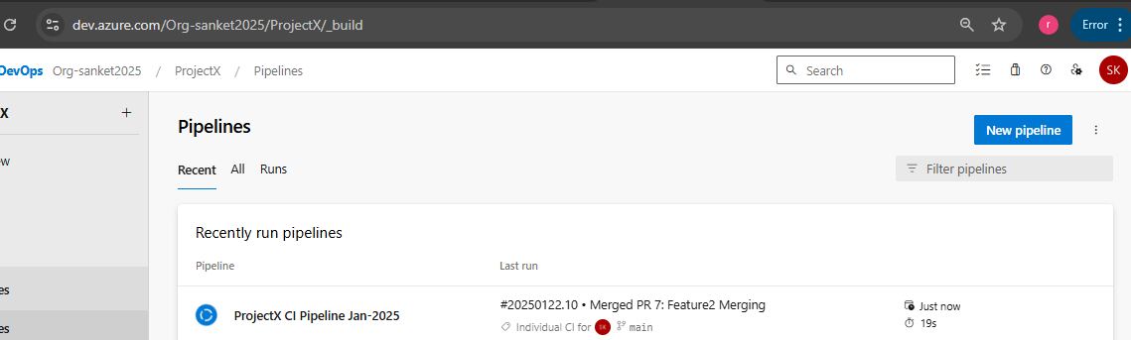

CI Pipeline Tasks executed successfully and below reports are generated

Unit Test case Report
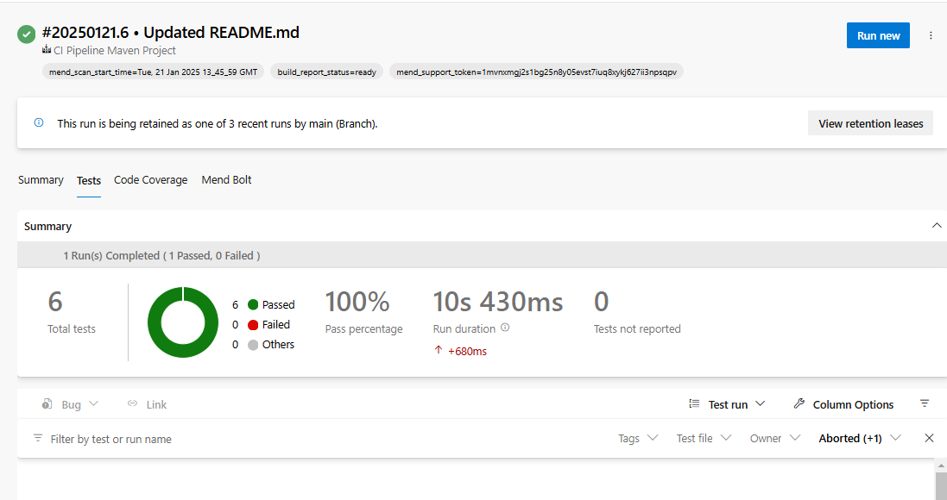
Code Coverage
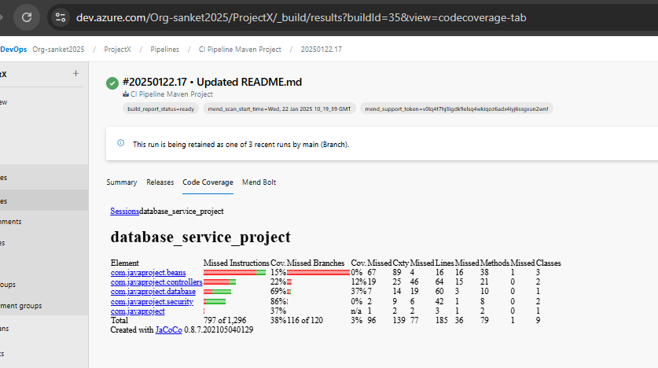

SonarQube Server portal – Output
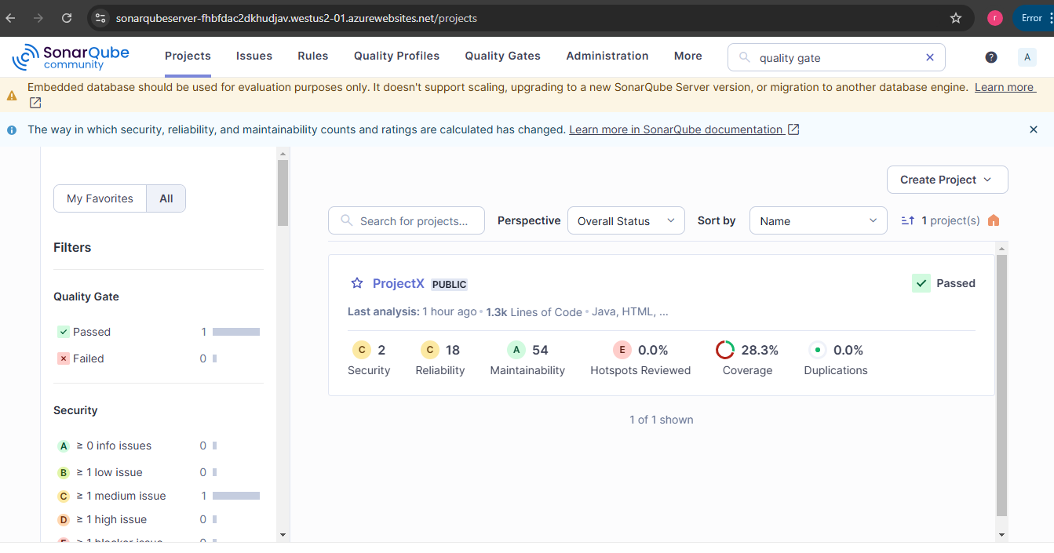

Mend Bolt Output – Go to Mend Tab in executed job instance
Mend Bold Inventory
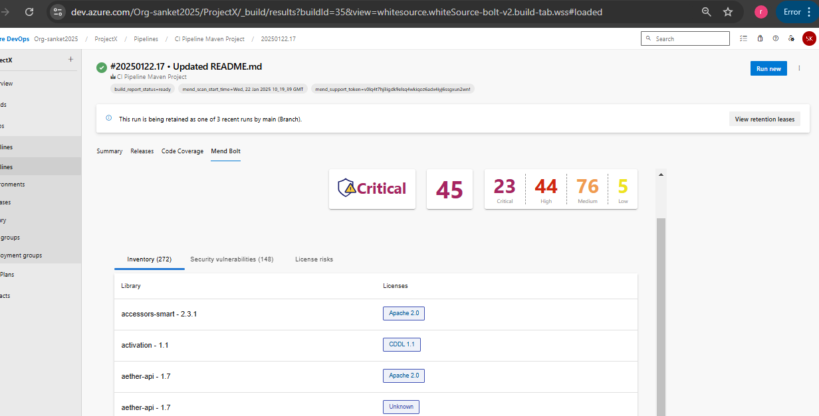

Mend Bold Security Vulnerability
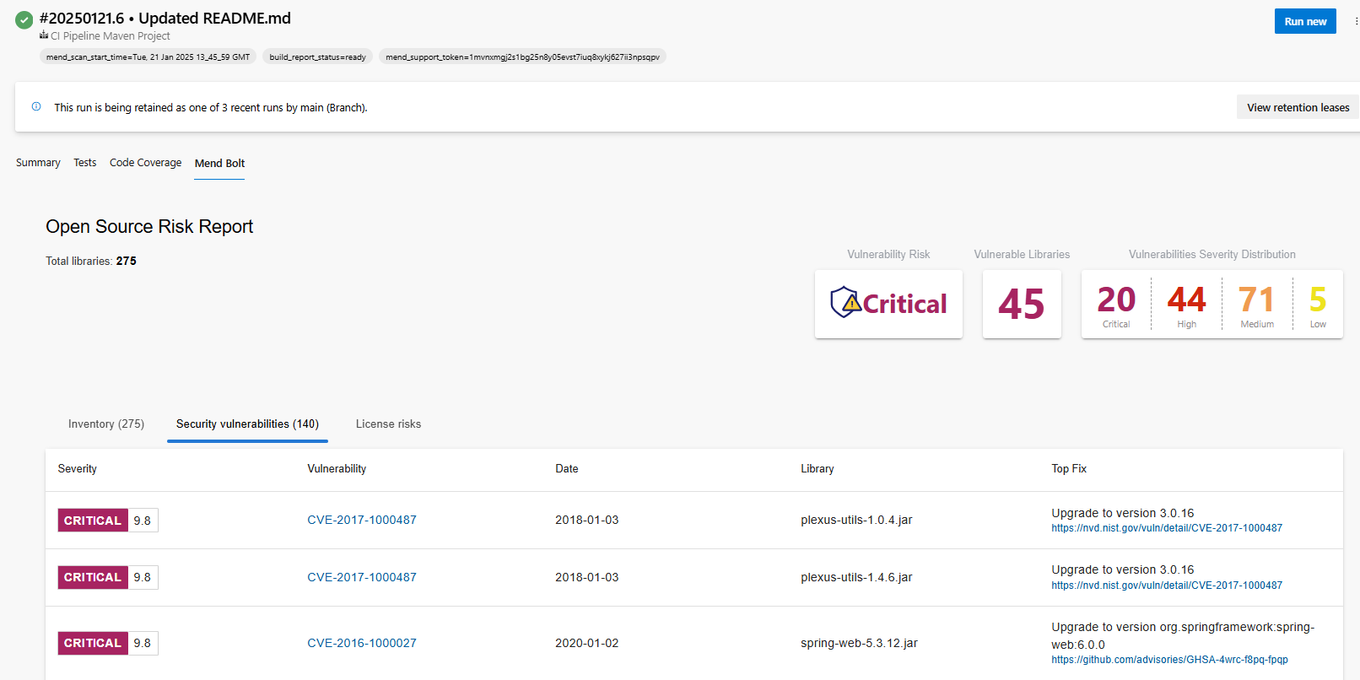
Mend Bold License Risk
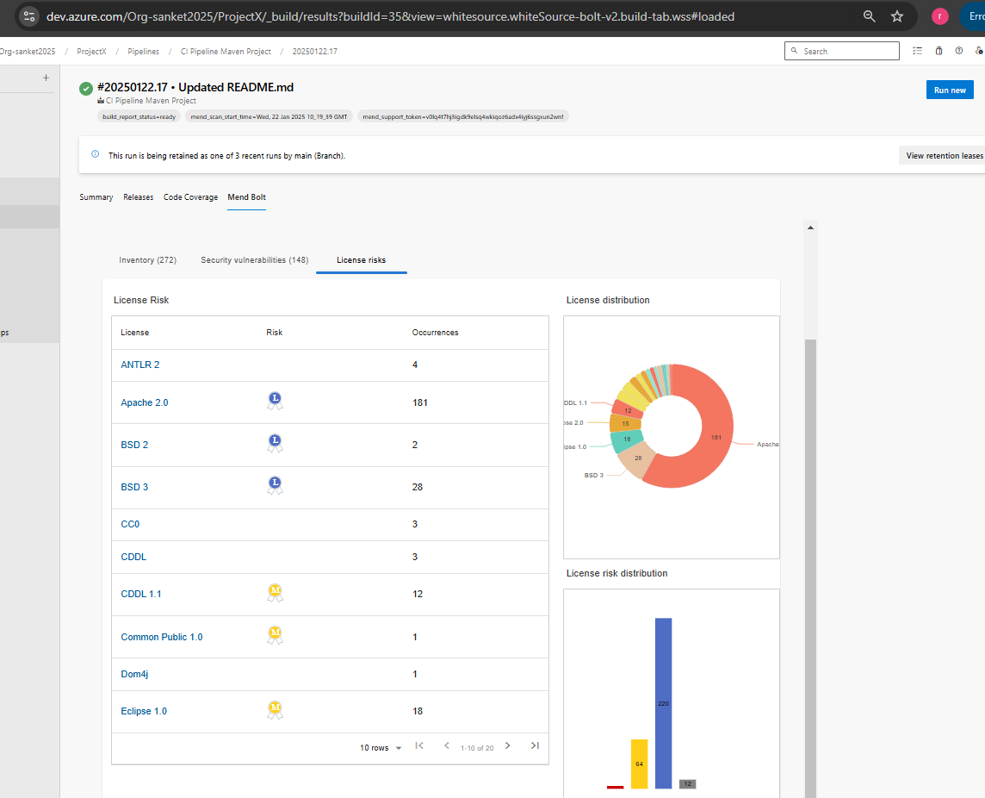

Release Pipeline - UAT Stage triggered automatically after CI pipeline completed and artifact generated
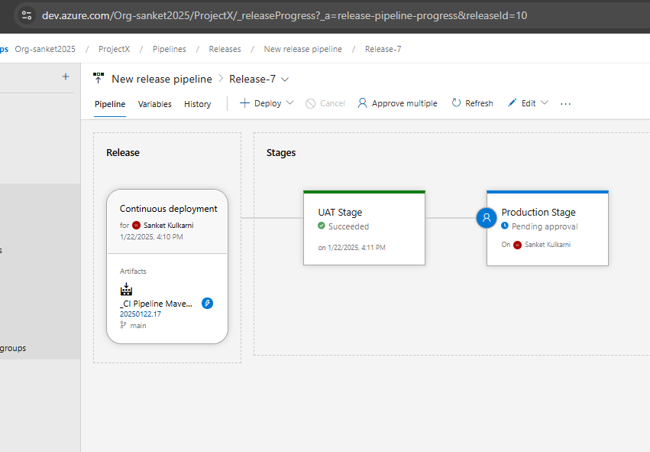

After UAT Stage successfully completed, Manual Approval required for Prod Deployment
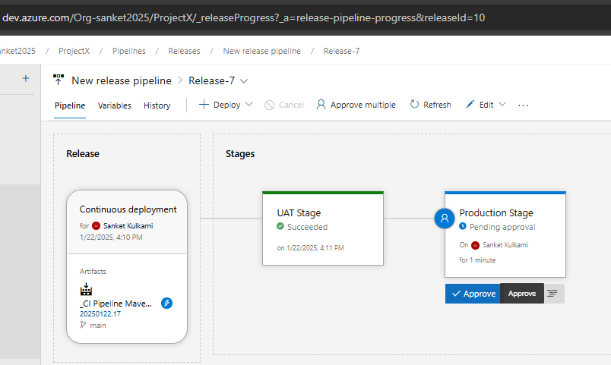
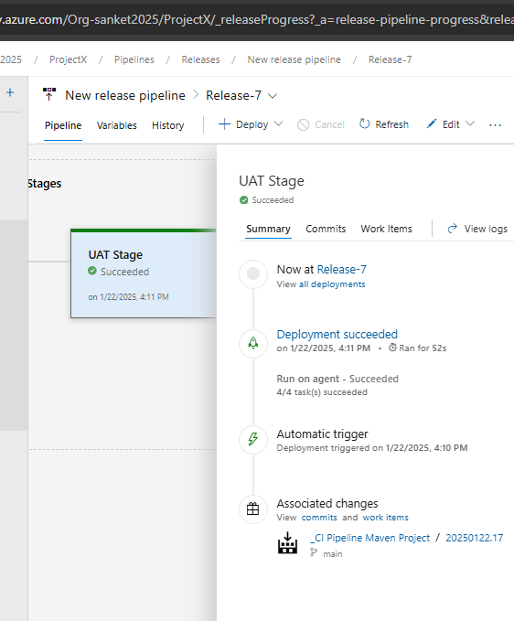
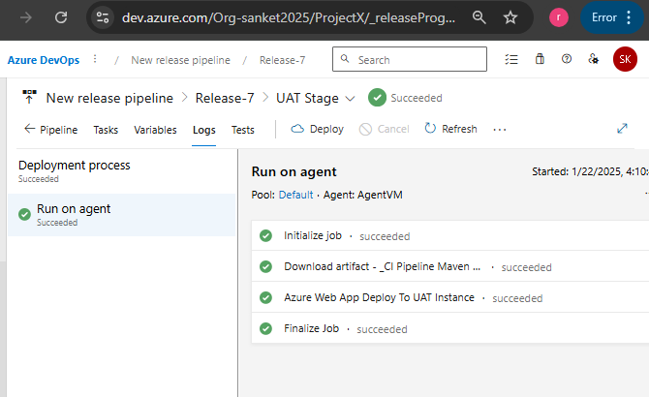
Approval Given by Authorized person -> Release pipeline Prod Stage will start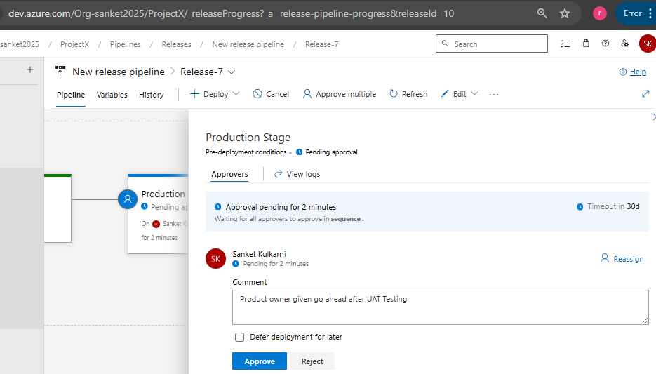

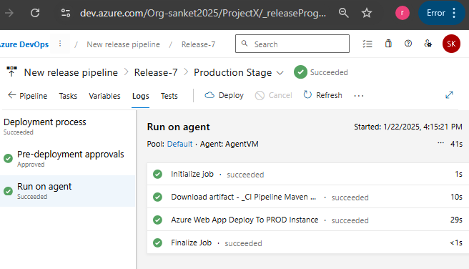

Web App Service URL opened to check the deployments
